**The dimensions of the original design are listed as follows:**

**Stator outer diameter:** 270 mm

**Stator inner diameter:** 180 mm

**Rotor inner diameter:** 120 mm (not a critical parameter, subject to change)

**Axial length:** 135 mm

**Magnet maximum thickness** (including the part inside rotor): 7 mm

**Air gap:** 1.5 mm

**The 24 slot/20 pole machine is shown in the figure below:**

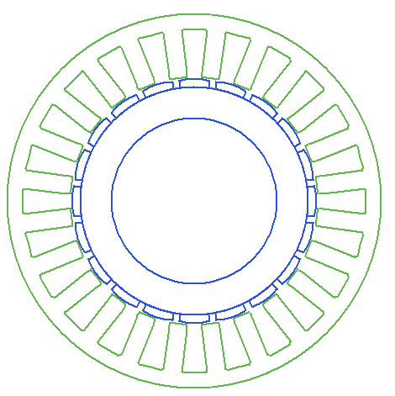

**Slot dimensions:**

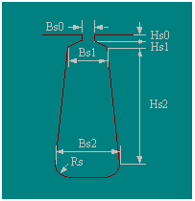

hs0 (mm): 2, hs1 (mm): 1, hs2 (mm): 30, bs0 (mm): 10.9, bs1 (mm): 11.3317, bs2 (mm): 19.2308

rs (mm): 1, bt (mm): 13 (this is a parallel tooth design)

**Slot area:** 510 mm2 (RMXprt calculation)

**Slot area:** 457 mm2 (calculation by hand)

**Net slot area:** 441 mm2 (RMXprt calculation)

**Winding:** AWG#21, 1.15mm diameter, 2 strand

**Single coil area:** 2.08 mm2

The original **number of turns per coil** **side** was **36**. The slot fill factor came out to be 0.4 (RMXprt).

Due to the drop of voltage, it is re-designed as **40**.

**Slot fill factor** (by hand): 0.364

**Slot fill factor** (RMXprt): 0.479

**Magnet: NdFe45H** (Br = 1.35 T, ur = 1.1)

**The resulting mass of the machine:**

Armature Copper Weight (kg): 5.8856

Permanent Magnet Weight (kg): 2.60259

Armature Core Steel Weight (kg): 19.1954

Rotor Core Steel Weight (kg): 9.88248 (this will drop)

Shaft, rotor, case etc. weights will be added.

**Total Net Weight (kg):** 37.566 + additions

**RMXprt results for flux density:**

Stator-Teeth Flux Density (Tesla): 1.47819

Stator-Yoke Flux Density (Tesla): 0.865389

Rotor-Yoke Flux Density (Tesla): 0.435899

Air-Gap Flux Density (Tesla): 0.889123

Magnet Flux Density (Tesla): 0.956717

**Resistance and inductance results:**

**Armature Phase Resistance R1 (ohm):** 0.277107

**L1 leakage:** 2.87 mH

**La armature:** 0.78 mH

**Ltotal:** 3.66 mH (phase)

**RMXprt performance data:**

Maximum Line Induced Voltage (V): 396.873 (**81 V phase rms**)

Root-Mean-Square Line Current (A): 16.5882 (**8.29 A phase rms**)

Root-Mean-Square Phase Current (A): 16.5882

Armature Thermal Load (A^2/mm^3): 112.435

Specific Electric Loading (A/mm): 28.1609

Armature Current Density (A/mm^2): 3.99257

Frictional and Windage Loss (W): 12

Iron-Core Loss (W): 96.4992

Armature Copper Loss (W): 228.752

Total Loss (W): 337.252

Output Power (W): 8002.44

Input Power (W): 8339.7

Efficiency (%): 95.9561

Synchronous Speed (rpm): 600

Rated Torque (N.m): 127.363

Torque Angle (degree): 12.5256

**RMXprt induced voltage waveform:**



In the 2D simulations, the stator is kept constant. Magnet thickness is **7 mm** with 1 mm inside the rotor. The magnet offset is set to **50 mm (?)**. The magnet embrace is kept as a design variable:

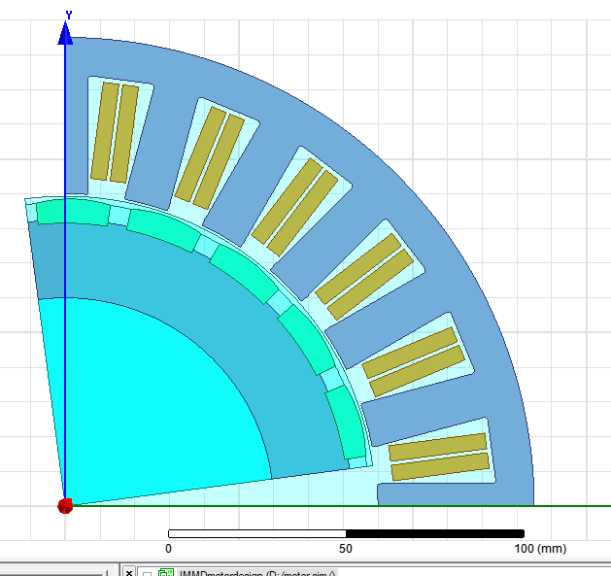

**Results with varying embrace are as follows:**

**Torque with excitation:**

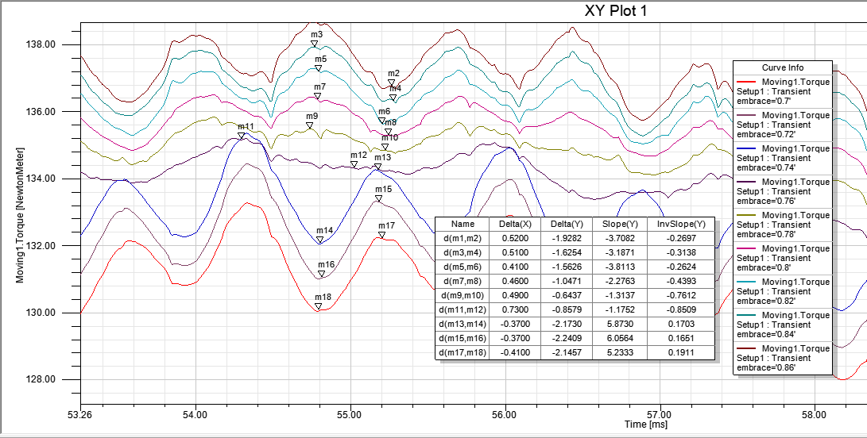

|  |  |  |
| --- | --- | --- |
| **Embrace** | **Torque ripple** | **Percent** |
| 0.70 | 2.15 Nm | 1.63 % |
| 0.72 | 2.24 Nm | 1.69 % |
| 0.74 | 2.17 Nm | 1.63 % |
| 0.76 | 0.85 Nm | 0.63 % |
| 0.78 | 0.64 Nm | 0.47 % |
| 0.80 | 1.05 Nm | 0.77 % |
| 0.82 | 1.56 Nm | 1.15 % |
| 0.84 | 1.63 Nm | 1.12 % |
| 0.86 | 1.93 Nm | 1.39 % |

**Torque without excitation:**

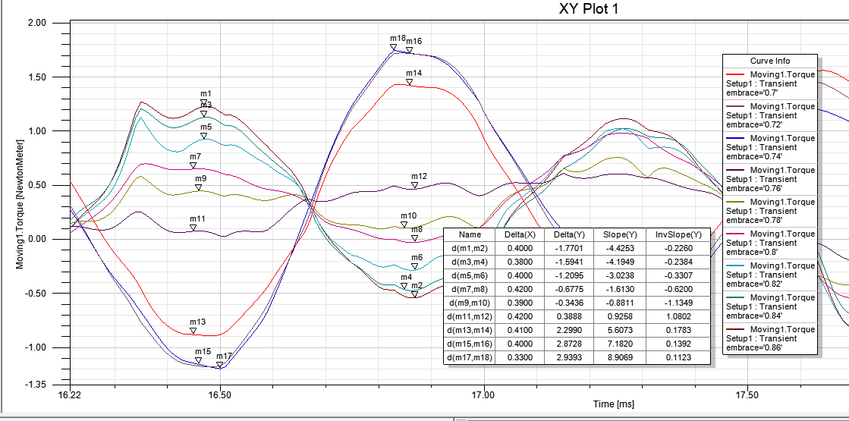

|  |  |  |
| --- | --- | --- |
| **Embrace** | **Cogging torque** | **Percent (/130Nm x 100)** |
| 0.70 | 2.29 Nm | 1.76 % |
| 0.72 | 2.87 Nm | 2.21 % |
| 0.74 | 2.93 Nm | 2.25 % |
| 0.76 | 0.38 Nm | 0.29 % |
| 0.78 | 0.34 Nm | 0.26 % |
| 0.80 | 0.68 Nm | 0.52 % |
| 0.82 | 1.21 Nm | 0.93 % |
| 0.84 | 1.59 Nm | 1.22 % |
| 0.86 | 1.77 Nm | 1.36 % |

**Induced voltage without excitation:**

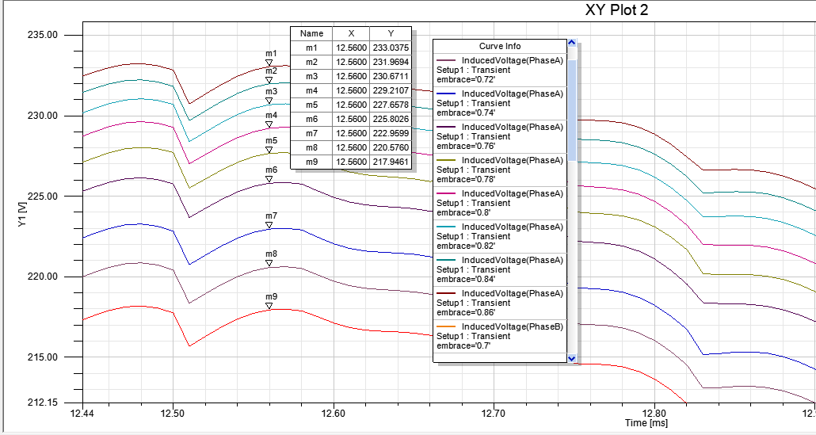

|  |  |  |
| --- | --- | --- |
| **Embrace** | **Voltage (peak)** | **Per module (rms)** |
| 0.70 | 217.9 V | 76.7 V |
| 0.72 | 220.6 V | 78.0 V |
| 0.74 | 222.9 V | 78.8 V |
| 0.76 | 225.8 V | 79.8 V |
| 0.78 | 227.6 V | 80.5 V |
| 0.80 | 229.2 V | 81.0 V |
| 0.82 | 230.7 V | 81.6 V |
| 0.84 | 231.9 V | 81.9 V |
| 0.86 | 233.0 V | 82.4 V |

**The resultant embrace is 0.78.** The magnet dimensions are as follows:



The length of the magnet (axial) is 67.5 mm. There will be 40 magnets in total. Magnets on each pole will be skewed by one half of the stator slot pitch.

**The 2D simulation results of the resultant motor design:**

**Torque without excitation:**

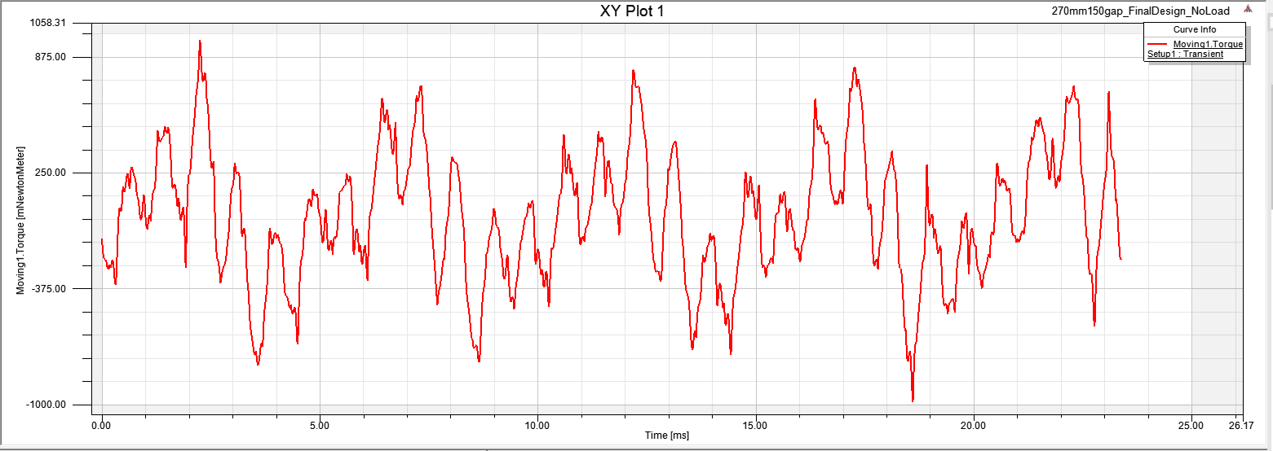

**Induced voltage without excitation:**

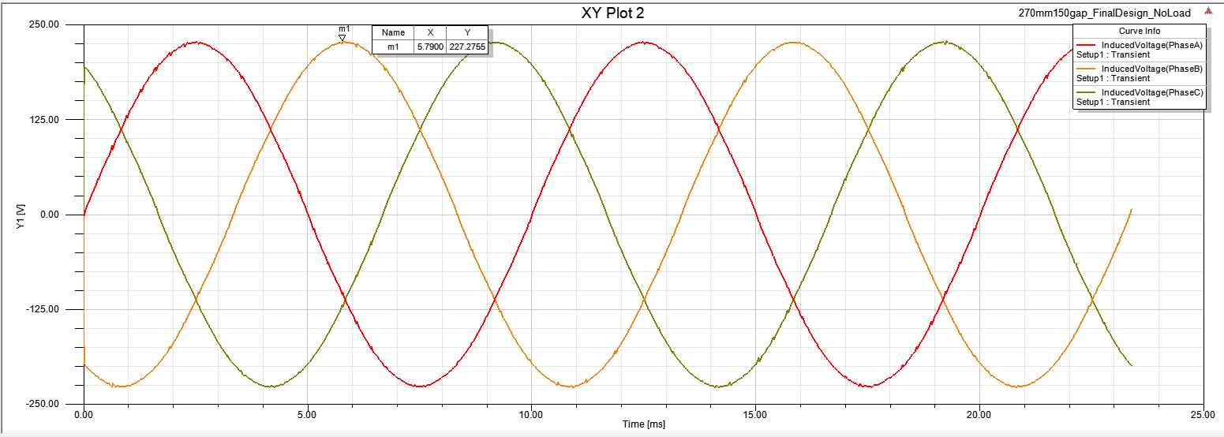

**Torque with excitation:**



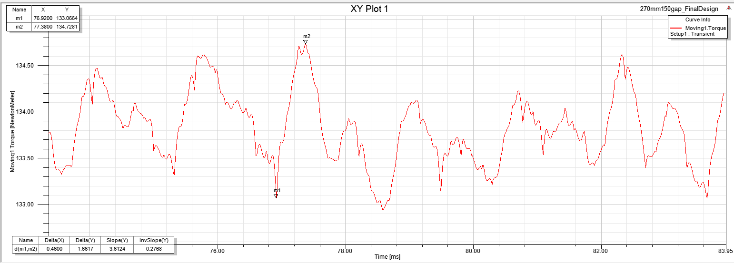

**Induced voltage with excitation:**



**Voltages and currents:**



**Line currents:**



**Flux density distribution:**

In the attached animation file.